XMT INVENTORY MANAGEMENT SYSTEM



User Interface (XMT Inventory System)



JavaScript (AJAX)

Python

SqLite3

QueryResponse

JSON/HttpResponse

The diagram shows the architecture of the system. This system uses Asynchronous JavaScipt and XML (AJAX) to send request to the server. At the server, the request is processed by the scripting language. The scripting language will query the database and the database will return a QueryResponse object. The QueryResponse object will be processed by the scripting language(Python) and the result will be returned in JavaScript Object Notation (JSON) or plain HttpResponse format. In this system, the scripting language is Python combined with the Django web framework. This architecture applies to most functionalities of this system add/update inventory, assigning inventory/deleting inventory for clients. This architecture is not used when the user clicks a URL or link where the request is directly sent by the browser.

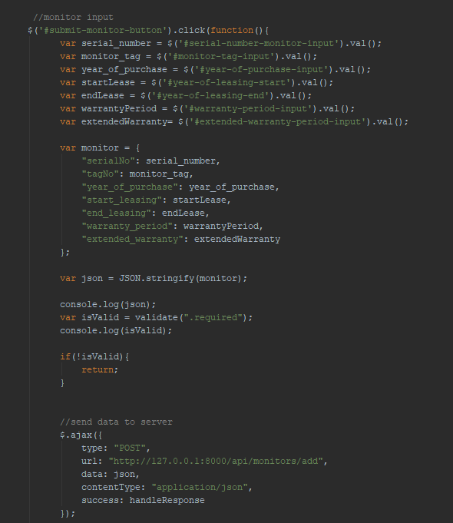

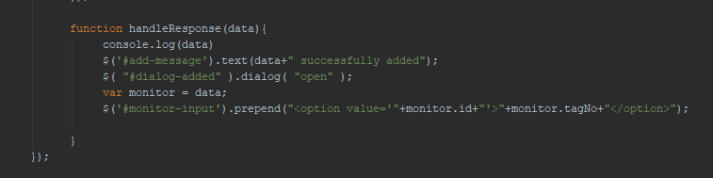

The image above shows the code snippet of an example request to add a monitor in the database. Please not that this is JavaScript JQuery syntax instead of the traditional JavaScript syntax. Basically, this code tells the browser that when the button with the ID ‘#submit-monitor-button’ (ID in HTML is marked using a # initial) is clicked, get all the value of the input based on their ID. Then, create a monitor object using the JSON format to prepare the data to be passed to the server. Before submitting the data to the server, validate all the required input using the validate(*classString*) function. The validate function checks all the class marked with “.required” (class in HTML is marked using dot . initial) if it is not empty i.e all the required fields are filled in. If all the required fields are filled in, the function will return true. Else it will return false.

Then the if statement checks the value of the isValid variable to test if the form is valid. If it is false, the function will return and exits the operation. If it is true, the function will continue executing.

The $.ajax function is the JQuery function for the AJAX request. The type parameter specifies the request type whether it is GET, POST or PUT request. The url parameter is to specify the resource locater to be processed by the server. The data parameter is the data that we will be sending the server to process. So, we put in the json variable the we have prepared earlier. The contentType is the type of data that we will be sending. The success parameter is the function that will be called when the server responds 200 (OK) which is the handleResponse function.

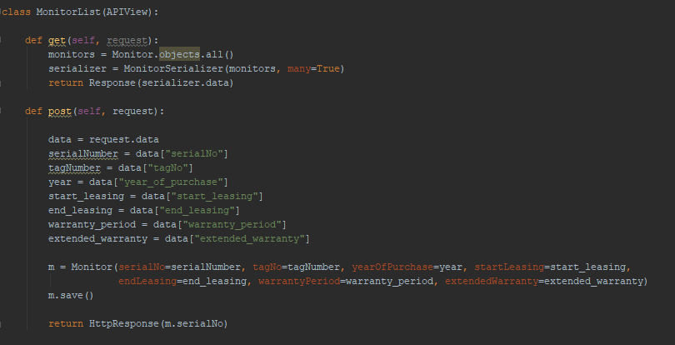

The image above shows the python code of the data that is processed when the user submits a new monitor to be added. Since this is a post request the post function will be executed. The first line of the function gets the data that is sent by the client which is the json data. The data will be processed using the key in the json request.

After retrieving all the information, create a monitor object and pass in all the required fields in the respective parameters. Finally the function will save it in the database using the m.save() command. The function will return to the client the serial number in the for of HttpResponse format. After this the handleResponse function at the client will be called to pop up a dialog indicating a successful adding of a new inventory.

Reference:

1. Jquery : i. <https://www.w3schools.com/Jquery/default.asp>

ii. <http://api.jquery.com/>

1. JSON: <https://www.w3schools.com/js/js_json_intro.asp>
2. Django <https://www.youtube.com/watch?v=qgGIqRFvFFk&index=1&list=PL6gx4Cwl9DGBlmzzFcLgDhKTTfNLfX1IK>

<https://docs.djangoproject.com/en/2.0/>

Source Code: <https://github.com/zafranZS/XMTInventory>